# **Caremark.Com - Submitting Web Support Help Tickets (WEF)Website**

|  |
| --- |
| **Process Demonstration – Video Walkthrough** |

Click [Web Error Form (WEF) Video Demonstration](https://thesource.cvshealth.com/nuxeo/thesource/#!/view?docid=ec5ad712-5388-47e2-b25c-1d371616e1fa) to view a video walkthrough of overall steps outlined in this job aid.

|  |
| --- |
| **Web Error Form – CVS VS. Vendor** |

If the member is experiencing an issue or error on Caremark.com website and you can confirm the error, a Web Error Form (WEF) ([Internal](https://thesource.cvshealth.com/nuxeo/thesource/#!/view?docid=a082ab2a-cbb5-4803-a27a-339f8c30cac9)) or ([Vendor](https://thesource.cvshealth.com/nuxeo/thesource/#!/view?docid=97f7ff71-4831-453d-b292-183506cab4d2)) might need to be submitted. Check Case Notes to determine if a WEF was previously submitted and resolved for the member.

* If there’s no WEF in the notes, submit a WEF.
* If there is a WEF opened, advise the member that their issue has been sent to the web support team for research.
* If there is a WEF that is closed, advise the member that their issue has been resolved and assist with navigation through the website.
* If there is a WEF that is closed but the member is having the same issue, create another WEF for research.

|  |
| --- |
| **Web Error Form Submission** |

**Fill out the Form, ensuring all fields are complete. Below are key reminders:**

 If this is a privacy issue, do not fill out this form. Refer to work instruction [Caremark.com - HIPAA Disclosures & Privacy Issues (068983)](https://thesource.cvshealth.com/nuxeo/thesource/#!/view?docid=0aca5d8e-b0ad-4d57-a4bb-78c3858feef5).

1. For Medicaid members, select **Commercial** as the Patient Type when completing the form.
2. Verify the member’s correct phone number and email address.
3. To add a member’s date of birth follow the steps below:
   1. Hover over the calendar icon to show the date selector.

* 1. Hover over the month, and click to select the member’s birth month.

* 1. Hover over the year, and click to select the member’s birth year. Click the left arrow to find the correct year.

* 1. Click to select the member’s birthday.

1. Include as much information and detail as possible in the Primary Issue Type.
2. Do **not** fill the section for Grievance Analyst unless the WEF is a result of a Medicare D grievance.
3. Attachments with screen captures showing the error can be uploaded and is located at the bottom of the form to aid with researching the issue.
4. To submit the form:
   1. CVS Internal: **Save and Submit**
   2. Vendors: **Submit**
5. You will receive a confirmation email after the form has been submitted.

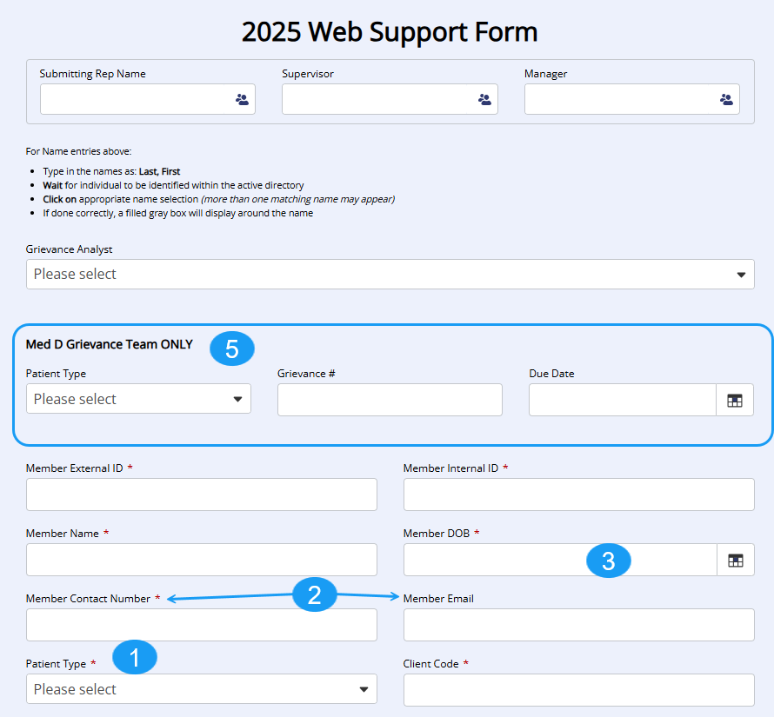

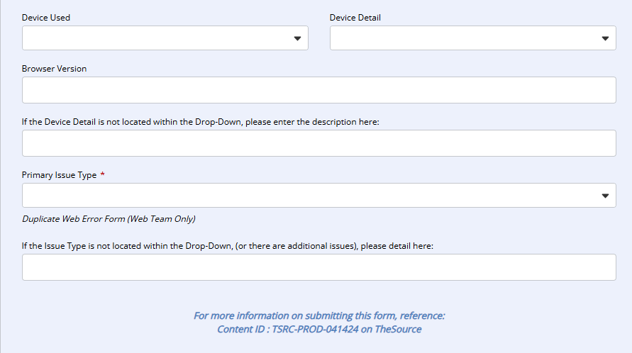

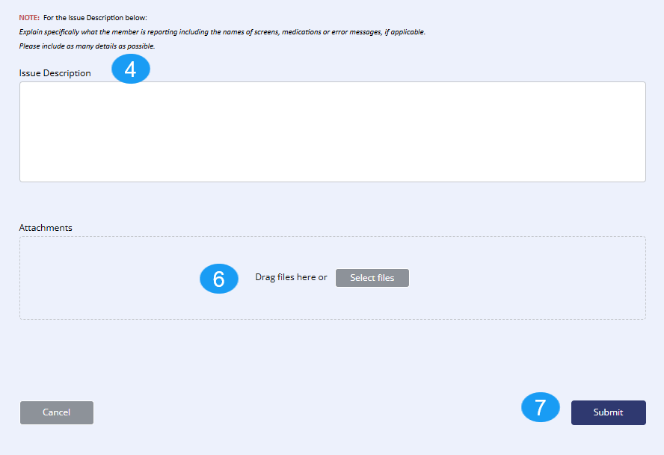

|  |
| --- |
| **Related Documents** |

[Caremark.com - Common Member Assistance Call Types Index](https://thesource.cvshealth.com/nuxeo/thesource/#!/view?docid=947b0b38-401d-4b18-a08e-60348558a9b9)

**Full Details Document:**  [Caremark.com – Web Error Form Process (Internal)](https://thesource.cvshealth.com/nuxeo/thesource/#!/view?docid=a082ab2a-cbb5-4803-a27a-339f8c30cac9)

**Full Details Document:**  [Caremark.com – Web Error Form Process (Vendor Teams Only)](https://thesource.cvshealth.com/nuxeo/thesource/#!/view?docid=97f7ff71-4831-453d-b292-183506cab4d2)

Not To Be Reproduced Or Disclosed to Others Without Prior Written Approval

**ELECTRONIC DATA = OFFICIAL VERSION / PAPER COPY = INFORMATIONAL ONLY**